**Manual for domain walls(DWs) structures construction using Python scripts**

**Contents**

Cartesian_direct.py : Convert Cartesian coordinate system to direct coordinate system

Direct_cartesian.py : Convert direct coordinate system to Cartesian coordinate system

O_90.py : construct 90° domain wall structure of orthorhombic phase

O_180_001.py : construct 180° domain wall structure of orthorhombic phase along 001 direction

O_180_100.py : construct 180° domain wall structure of orthorhombic phase along 100 direction

R_71.py : construct 71° domain wall structure of rhombohedral phase

R_109.py : construct 109° domain wall structure of rhombohedral phase

R_180_A_Ising.py : construct 109° domain wall structure of rhombohedral phase

T_90.py : construct 90° domain wall structure of tetragonal phase

T_180_A_ising.py : construct A centered Ising type 180° domain wall structure of tetragonal phase

T_180_A_ising_Bloch_Anti.py : construct A centered mixed Ising-Bloch type 180° domain wall structure of tetragonal phase(Bloch component: antiparall )

T_180_B_Ising.py : construct B centered Ising type 180° domain wall structure of tetragonal phase

T_180_B_Ising_Bloch_Anti.py : construct B centered mixed Ising-Bloch type 180° domain wall structure of tetragonal phase(Bloch component: antiparall )

T_180_nm0 : construct (nm0)-oriented building block for DW structure construction

**Procedure**

First, prepare the POSCAR of building block for DWs structure construction.

Second, run corresponding script to construct DWs structure.

Note: for all scripts, the input file is “POSCAR.0” and output file is “POSCAR”. The size of supercell can be tuned by variable n in subfunctions of in the main function.

**Examples**

Example1: (100)-oriented A-centered(or B-centered) Ising(or Ising-Bloch) type 180° DWs structure

Scripts: T_180_A_ising.py, T_180_A_ising_Bloch_Anti.py, T_180_B_Ising.py, T_180_B_ising_Bloch_Anti.py

Take T_180_A_ising.py as an example.

First, prepare the POSCAR of a unit cell, name the file as “POSCAR.0”. The “POSCAR.0” are as follows:

PbTiO3

1.00000000000000

3.8672948179140714 0.0000000000000000 0.0000000000000000

0.0000000000000000 3.8672948179140714 0.0000000000000000

0.0000000000000000 0.0000000000000000 4.0321616359809260

O Ti Pb

3 1 1

Direct

0 0.5 0.398257956

0.5 0 0.398257956

0.5 0.5 0.911755967

0.5 0.5 0.466524961

0 0 0

Then, construct the n×1×1 supercell containing DWs using “Python3 T_180_A_Ising.py”. The output file is ”POSCAR”. The size of supercell can be tuned by n, which are in the main function at the last part of the script, as shown in Fig. 2.

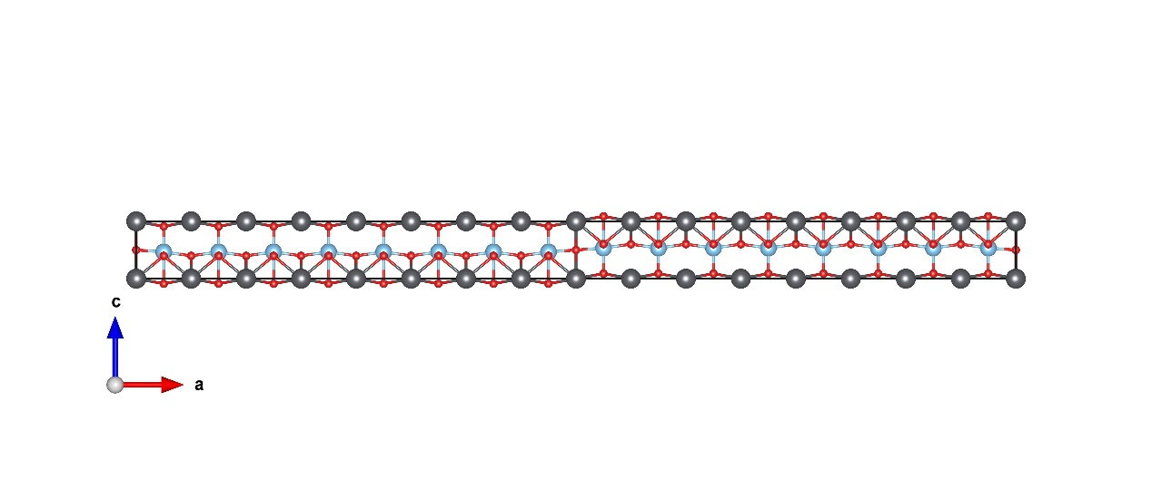

Fig. 1. A centered Ising type 180° domain wall structure of tetragonal phase

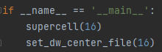

Fig. 2. Main function of T_180_A_Ising.py script. The size of n×1×1 supercell can be tuned by variable n in two subfunctions. (here, n=16)

Example2: Tetragonal PbTiO3 : 180° (140)-oriented Ising type DWs structure.

Script : T_180_nm0 and T_180_A_ising.py

First, prepare the POSCAR of a unit cell, name the file as “POSCAR.0”.

Second, obtain the POSCAR of the building block using “python3 T_180_nm0”, then name the file as “POSCAR.0”. The building block are shown in Fig. 3. The main functoin are shown in Fig. 4.

Third, construct the n×1×1 supercell containing DWs using “Python3 T_180_A_Ising.py”.

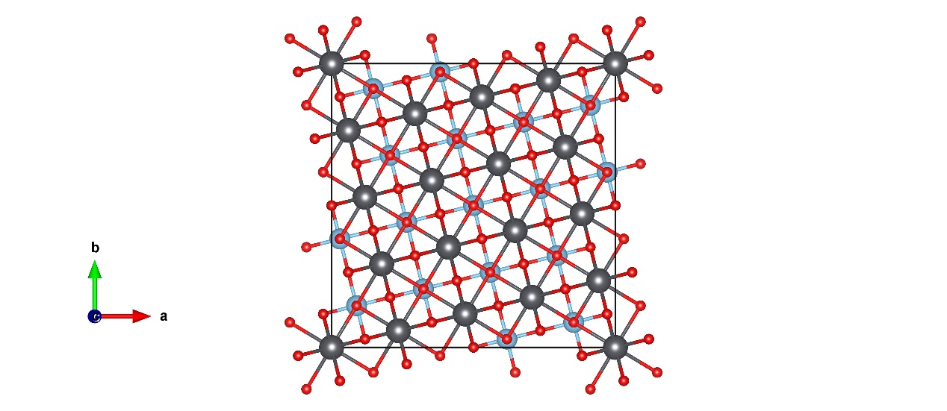

Fig. 3. Building block for (140)-oriented DWs structure construction of tetragonal phase

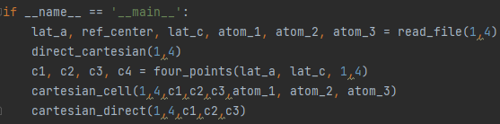

Fig. 4. Main function of T_180_nm0.py script. The orientation of building block can be tuned by variable n, m in five subfunctions.(here, n=1, m=4)

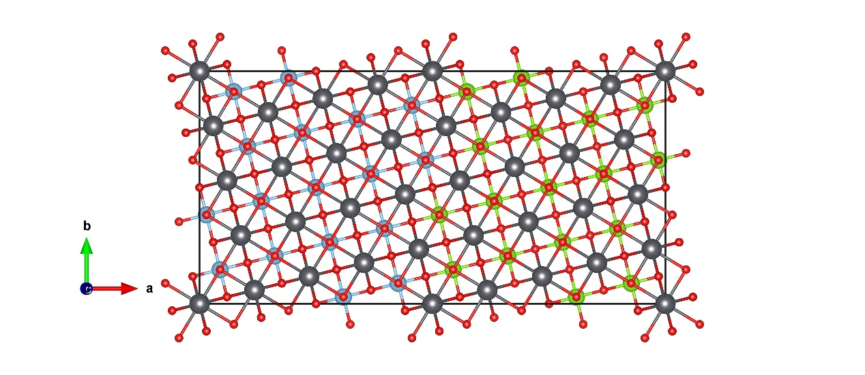

Fig. 5. 2×1×1 (140)-oriented DWs structure construction of tetragonal phase. Left part: polaization is along +z; Right part: polarization is along -z.

Example3: 90° domain wall of tetragonal PbTiO3

Script: T_90.py

First, prepare the POSCAR of a unit cell, name the file as “POSCAR.0”.

Second, obtain the POSCAR file of the 90° DWs structure using “python3 T_90.py”, as shown in Fig. 6.

Note: There are also some temporary files after running the T_90.py script. Only the POSCAR is the final output file.

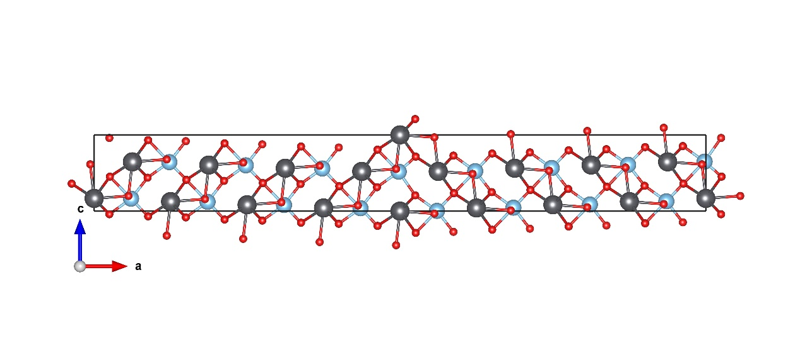

Fig. 6. 90° DWs of tetragonal ABO3 pervoskite

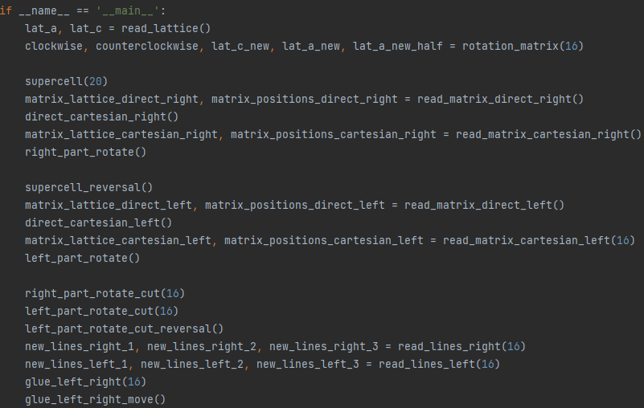

Fig. 7. Main function of T_90.py script. The size of supercell can be tuned by variable n in seven subfunctions. (here, n=16)

Example4: 90° domain wall of orthorhombic BaTiO3

Script: O_90.py

First, prepare the POSCAR of a 5-atom primitive cell, name the file as “POSCAR.0”, as shown in Fig. 7.

Second, obtain the POSCAR file of the 90° DWs structure using “python3 O_90.py”, as shown in Fig. 8.

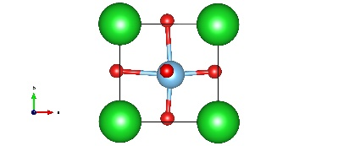

Fig. 7. 5-atom primitive cell

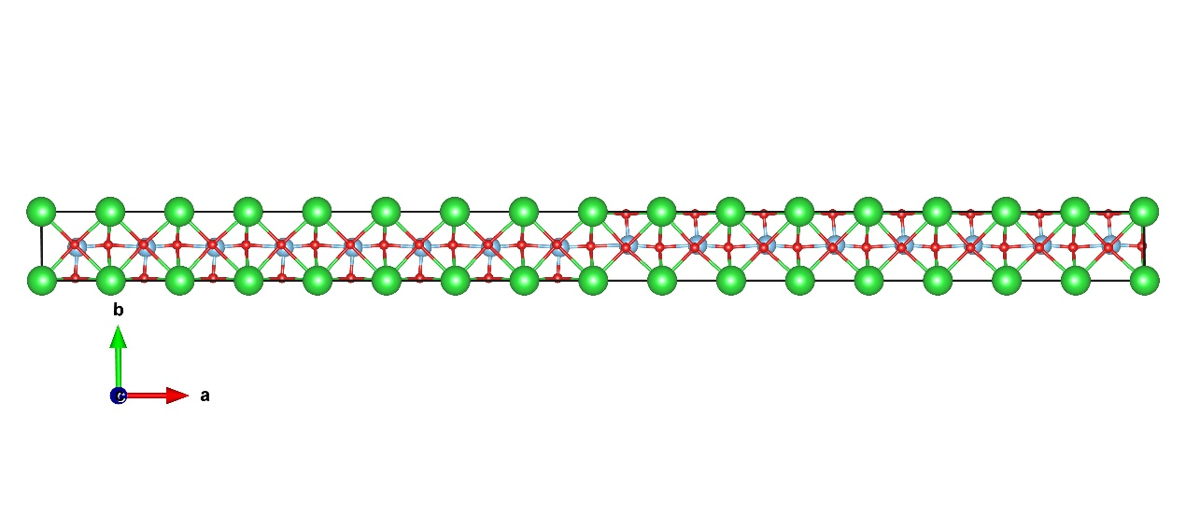

Fig. 8. 90° DWs of tetragonal ABO3 pervoskite

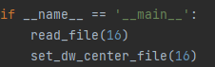

Fig. 9. Main function of O_90.py script. The size of n×1×1 supercell can be tuned by variable n in two subfunctions. (here, n=16)

Example5: 180° domain wall of orthorhombic BaTiO3

Script: O_180_001.py, O_180_100.py

First, prepare the POSCAR of a 10-atom conventional cell, name the file as “POSCAR.0”, as shown in Fig. 10.

Second, obtain the POSCAR files of the (100)-oriented or (001)-oriented 180° DWs structure using “python3 O_180_100.py” or “python3 O_180_001.py”, as shown in Fig. 11.

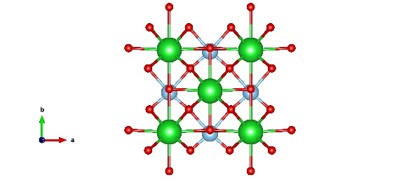

Fig. 10. 10-atom conventional cell

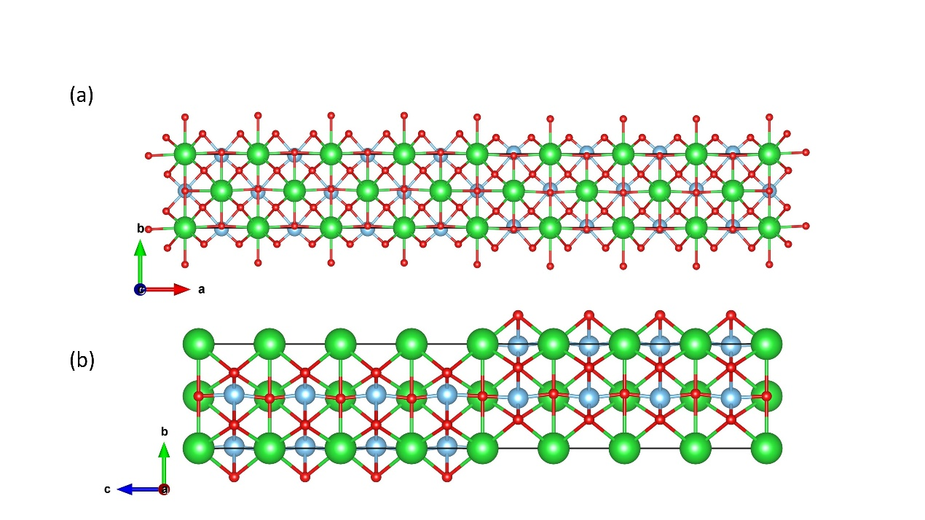

Fig. 11. (a) (100)-oriented and (b) (001)-oriented 180° DWs of orthorhombic ABO3 pervoskite

Example6: 109° domain wall of rhombohedral BaTiO3

Script : R_109.py

First, prepare the POSCAR of a 5-atom primitive cell, name the file as “POSCAR.0”, as shown in Fig. 12.

Second, obtain the POSCAR files of the 109° DWs structure using “python3 R_109.py” , as shown in Fig. 13.

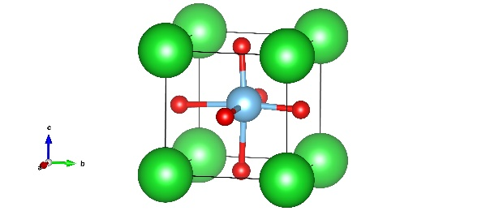

Fig. 12. 5-atom primitive cell of rhombohedral BaTiO3

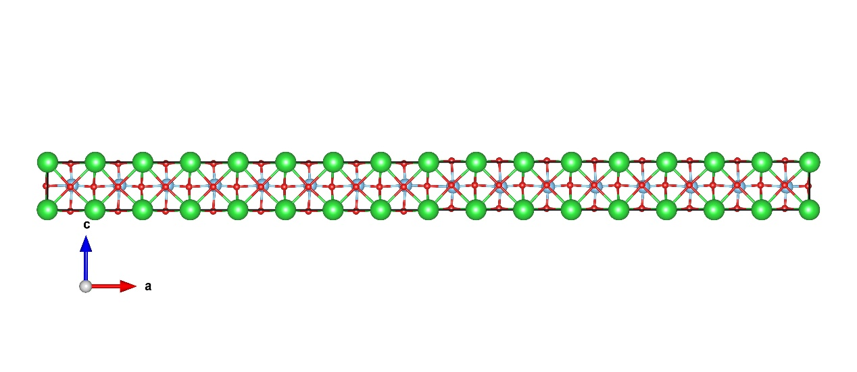

Fig. 13. 109° DWs of rhombohedral ABO3 pervoskite

Example7: 71° or 180° domain wall of rhombohedral BaTiO3

Script : R_71.py and R_180.py

First, prepare the POSCAR of a 10-atom building block, name the file as “POSCAR.0”. The building block can be obtained by VESTA using the transformation matrix“1 1 0 -1 1 0 0 0 1”, as shown in Fig. 14.

Second, obtain the POSCAR files of the 71° or 180° DWs structure using “python3 R_71.py” or “python3 R_180.py” , as shown in Fig. 15.

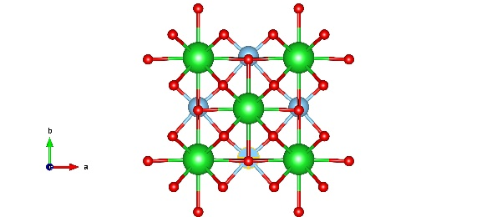

Fig. 14. 10-atom building block of rhombohedral BaTiO3

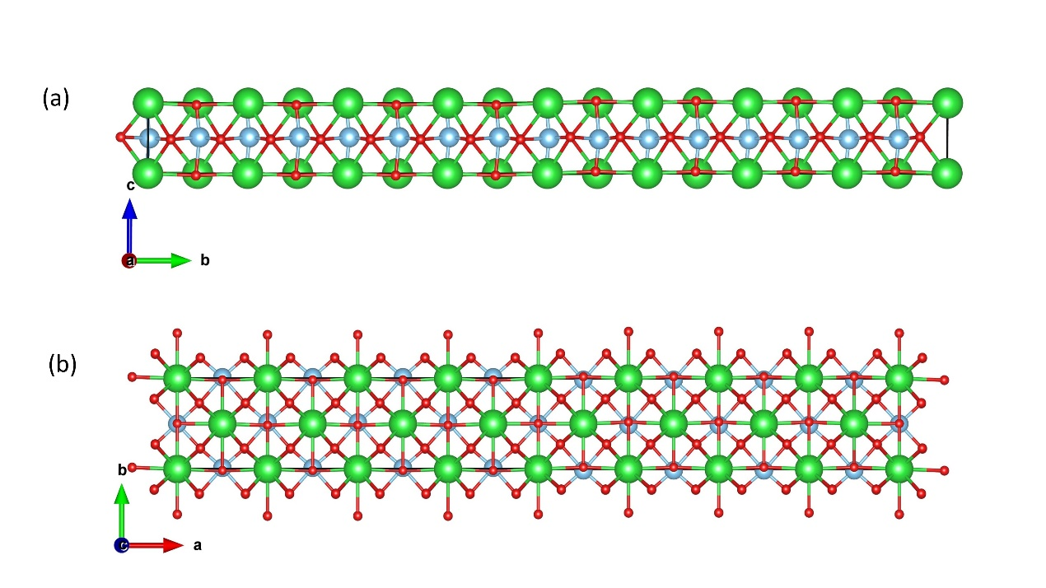

Fig. 15. (a)71° and (b)180° DWs of rhombohedral ABO3 pervoskite

Example7:

Cartesian_direct.py : Convert Cartesian coordinate system to direct coordinate system using “Python3 Cartesian_Direct.py”

Direct_cartesian.py : Convert direct coordinate system to Cartesian coordinate system using “Python3 Direct_Cartesian.py”